In the maintenance view you cannot view the records unless you use table maintenance generator.

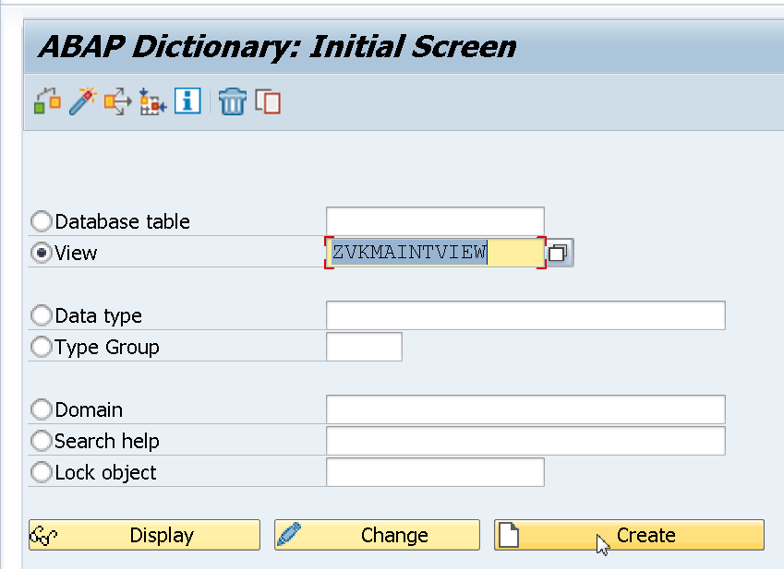

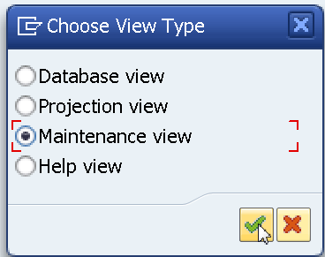

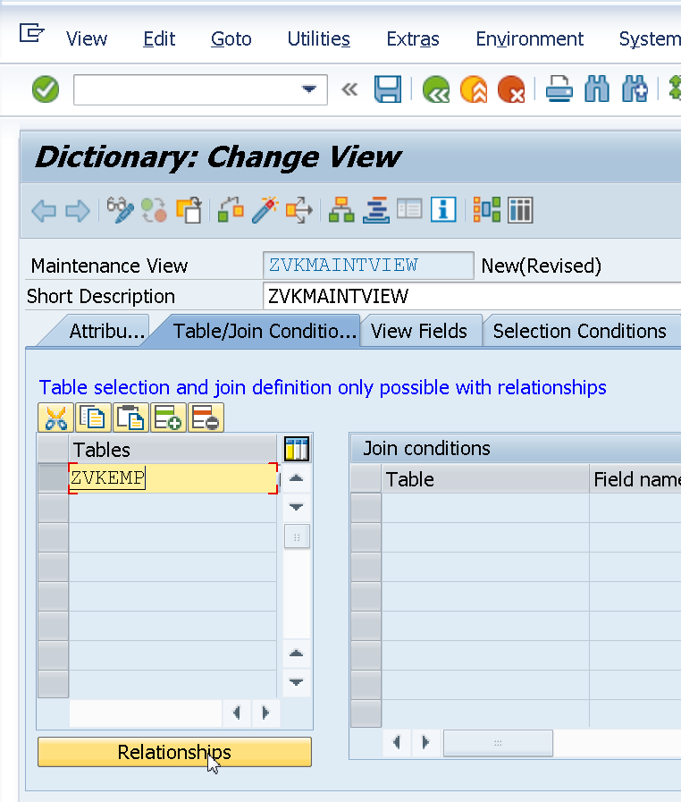

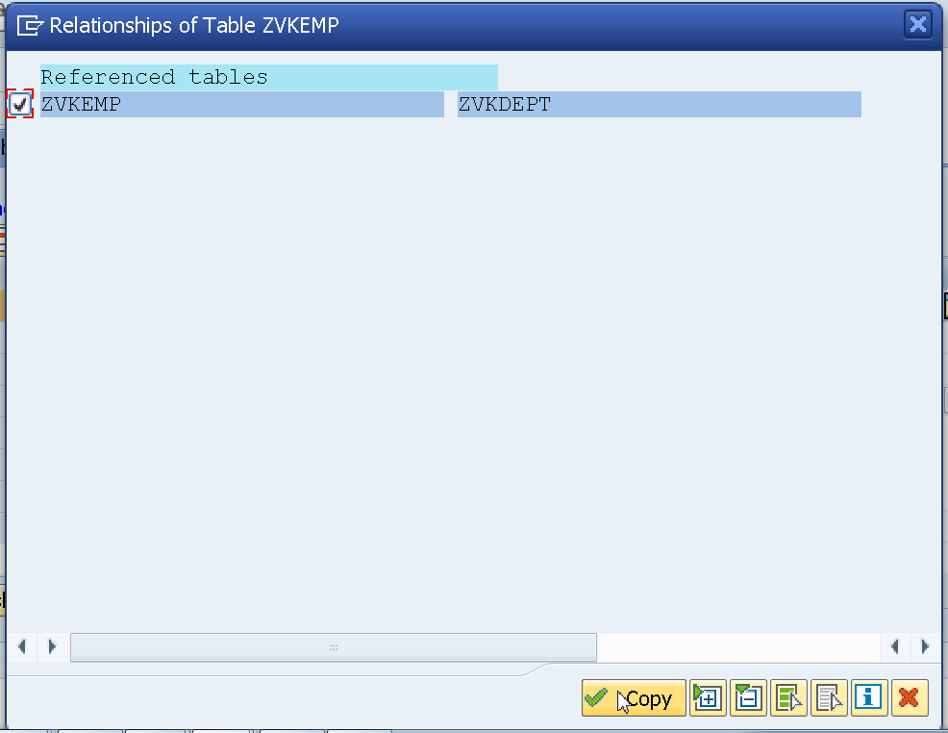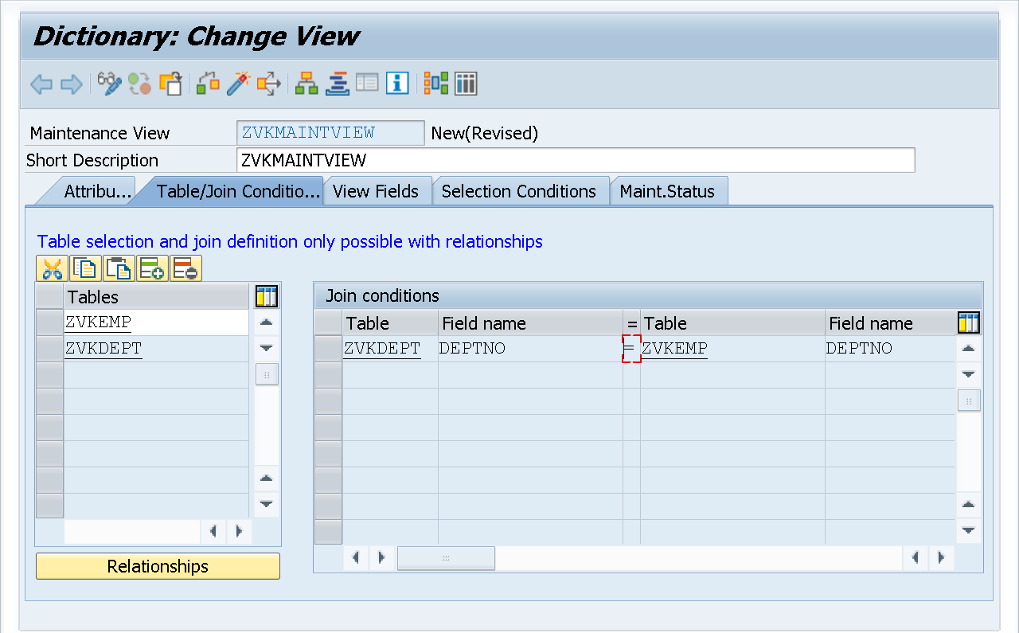

I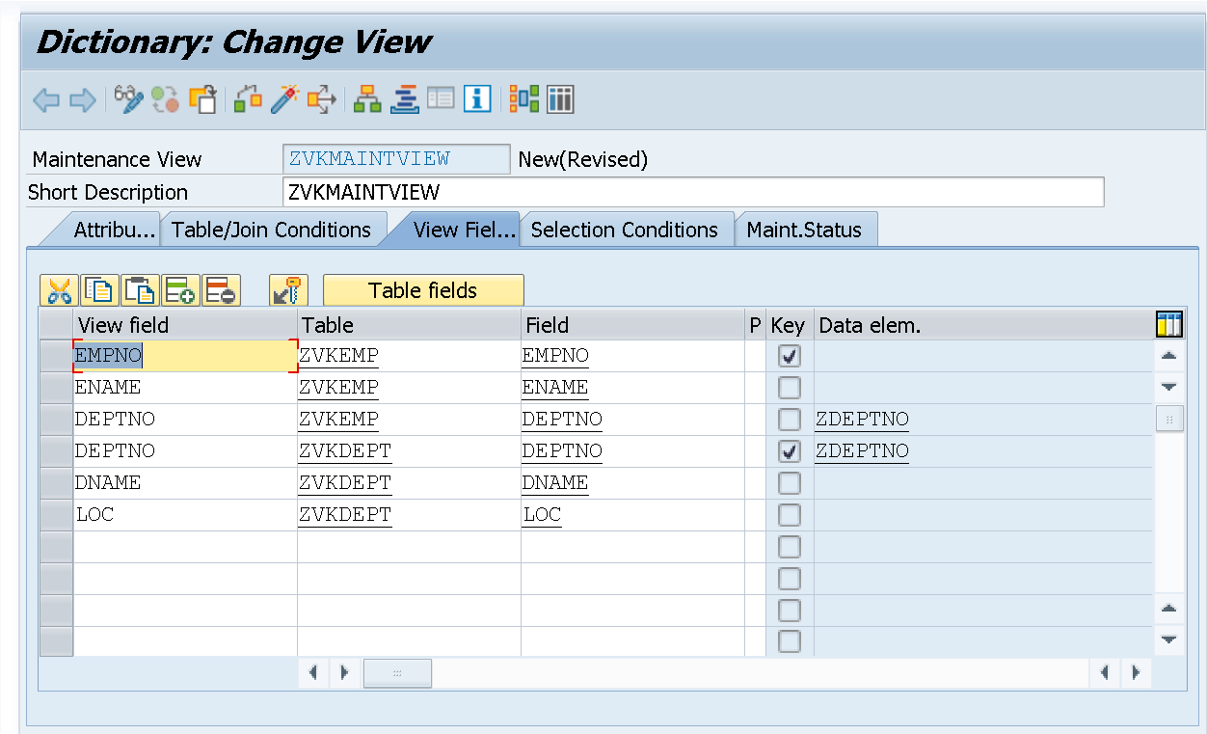

If we activate the above view, it gives error as Deptno not unique. So we can change the name of display field as deptdeptno.

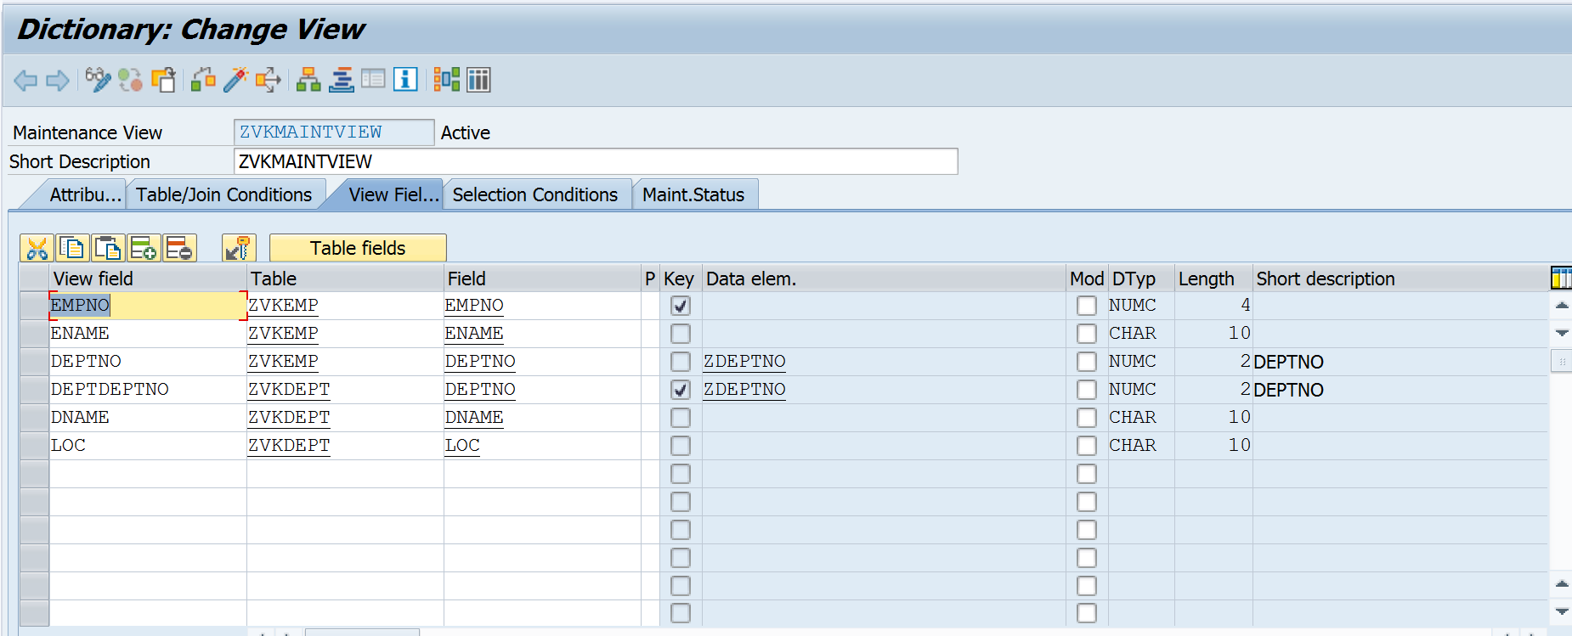

Maintenance view can be modified by Table Maintenance generator.

In Table Maintenance generator select a function group. The function group is already created in se80.

The function group contains an include required by Table Maintenance generator. Hence it has to be created in se80 and is selected here.

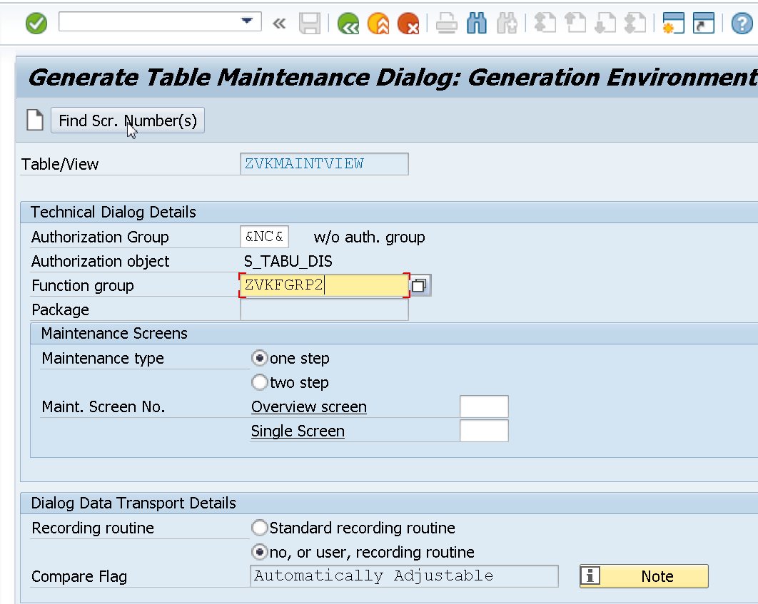

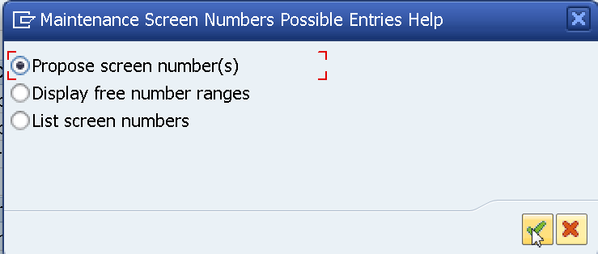

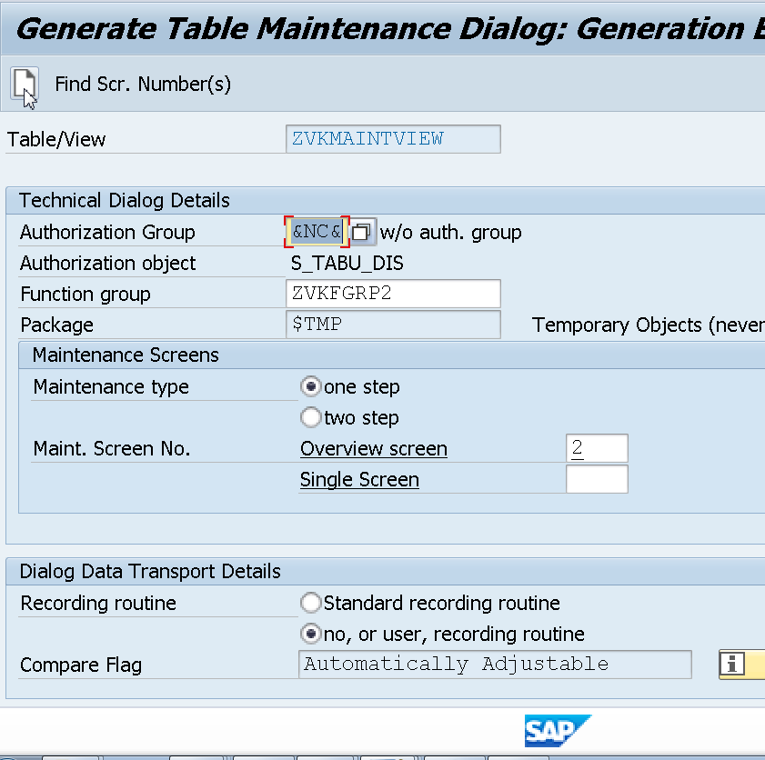

Since I am using this function group in the table maintenance generator for the second time, Overview screen is displayed as 2. Select on create icon above.

Save the above.

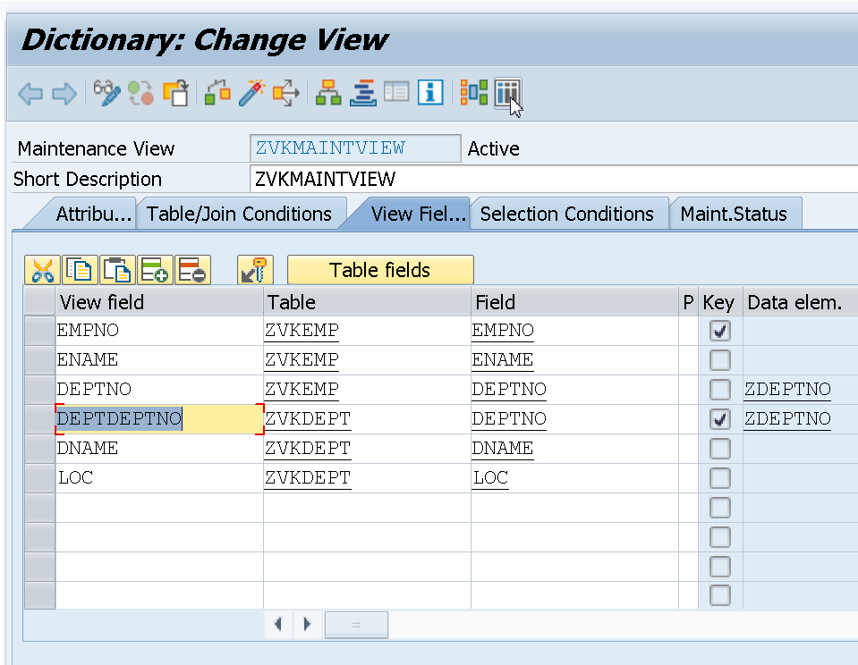

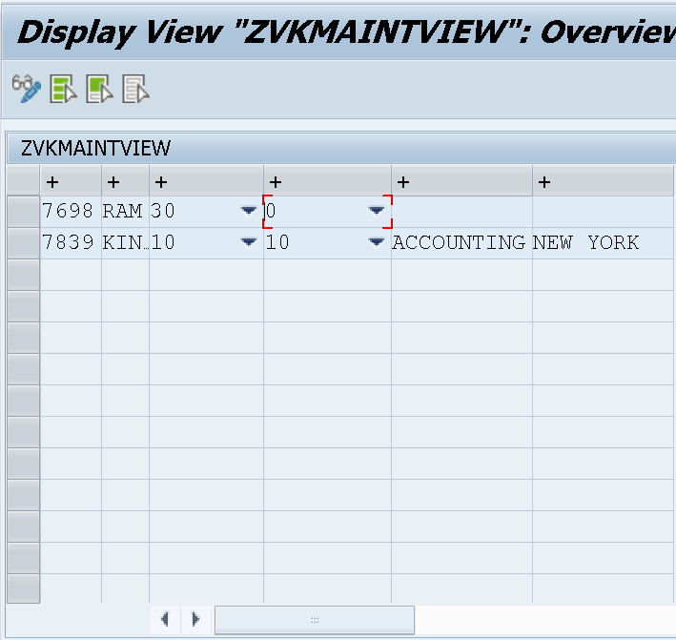

Click on the change icon and change name of Ram to Blake. Go to se11 and see the record changed in zvkemp table.

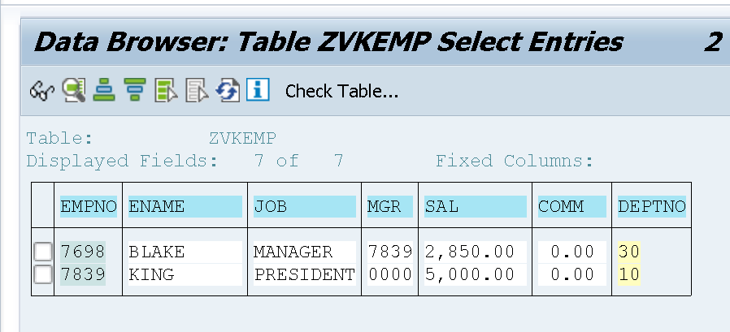

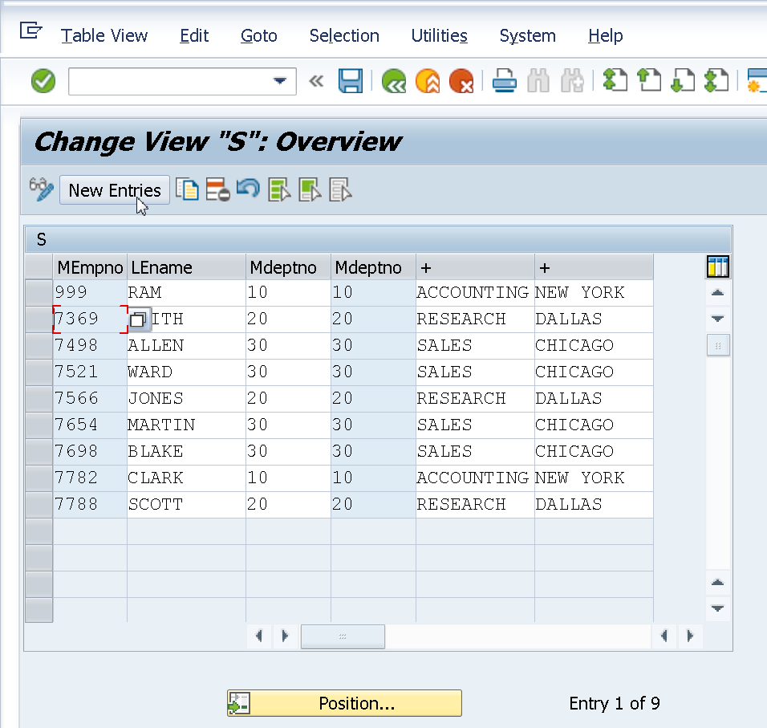

You can add records. The records gets added to the respective table.